S3 and route53 task:
- Configure VPC peering in cross regions.
Created the peering request for different region.
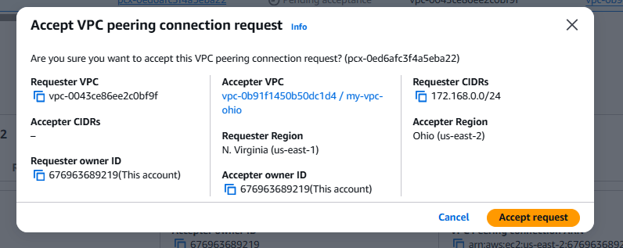
- Purchase one domain from GoDaddy. 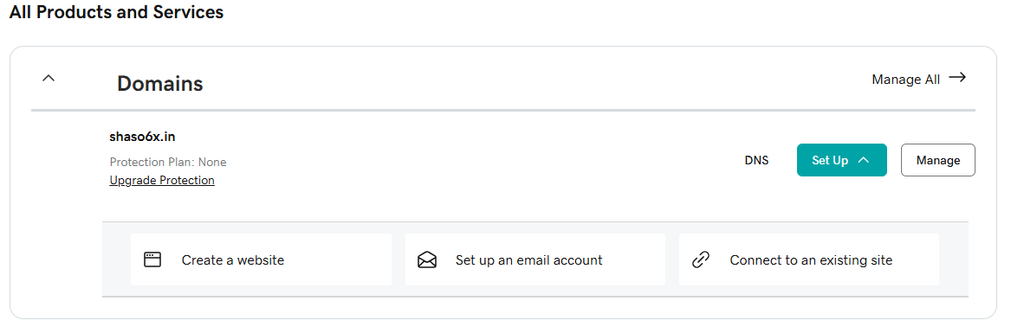

- Deploy static website in S3.
Created a new file and uploaded to the static website hosting page.
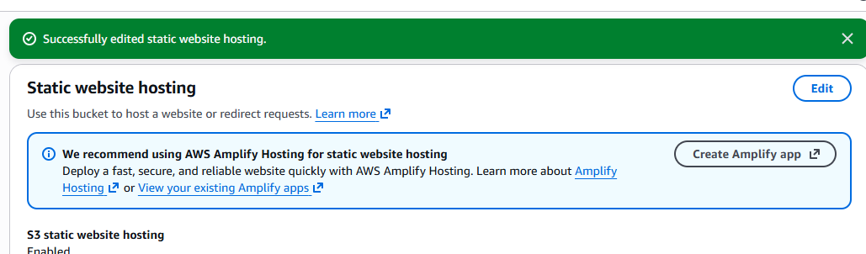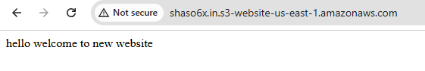
- Create a CDN and attach one SSL certificate.
Created a hosted zone for new distribution. 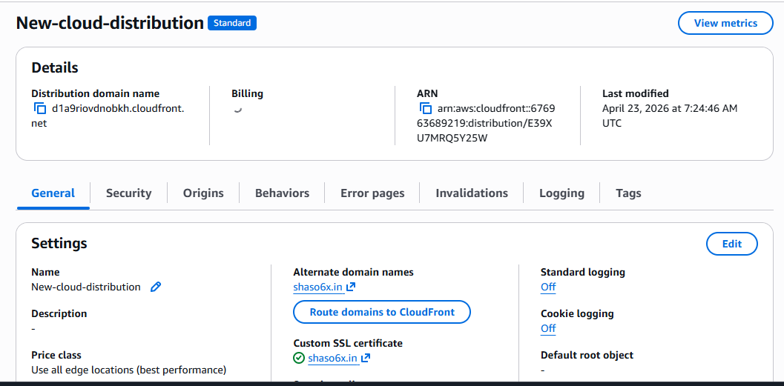

Changed the DNS setting with godaddy:
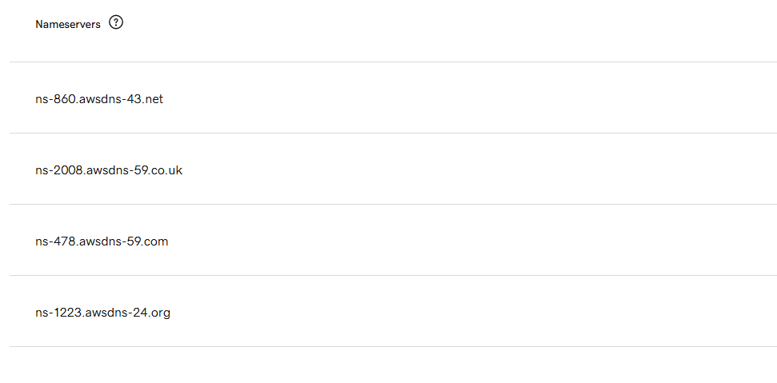
created a new certificate. 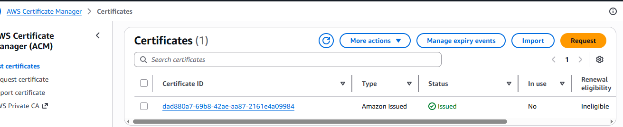

Tested with distribution domain name: 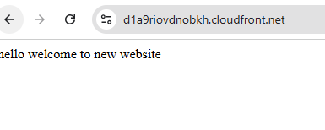

Tested with domain name:
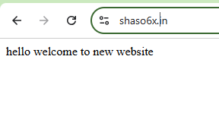

- Create a Route 53 hosted zone and map the domain with the CDN. 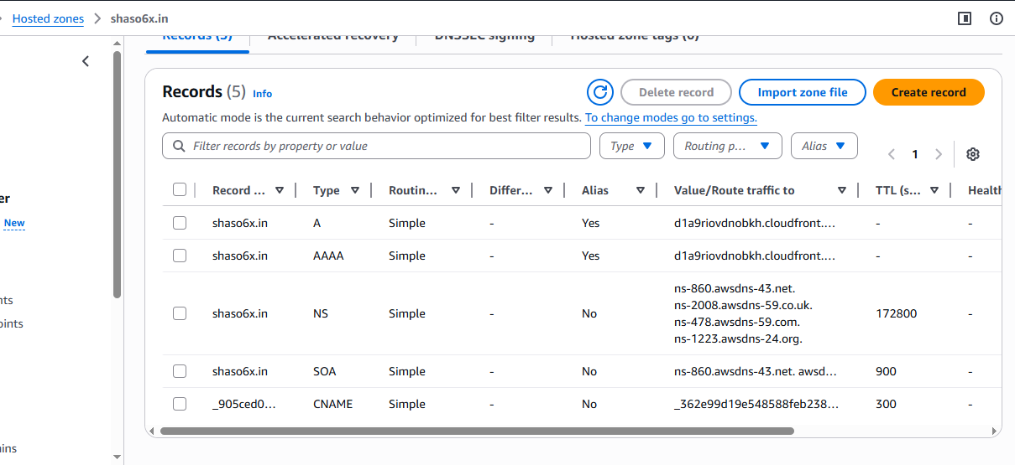
- Update the index.html in the S3 bucket and ensure the updated file is accessible using the domain name.
Created a new invalidation: 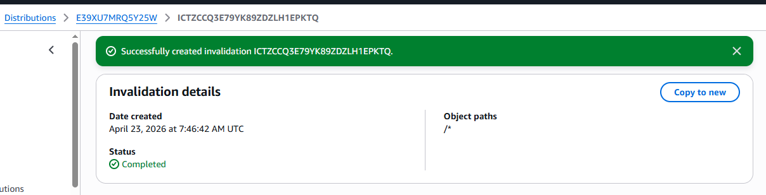
Enabled the bucket versioning:
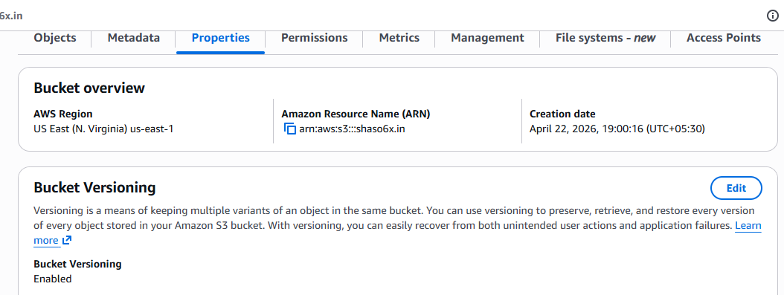
Tested with domain name:

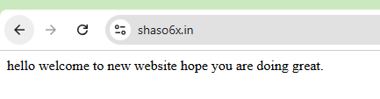
Tested with distribution domain name
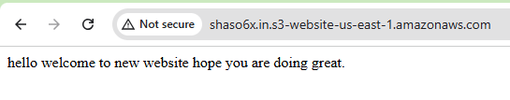
- Share the domain name in Slack to test the connectivity.
Shaso6x.in

